“SUMMER DAYS” by GEORGIA O'KEEFFE
Whitney Stories | Human Interest: Portraits from the Whitney’s Collection
Whitney Museum of American Art
April 2, 2016 – February 12, 2017
http://whitney.org/WhitneyStories/RobertBuckOnGeorgiaOKeeffe

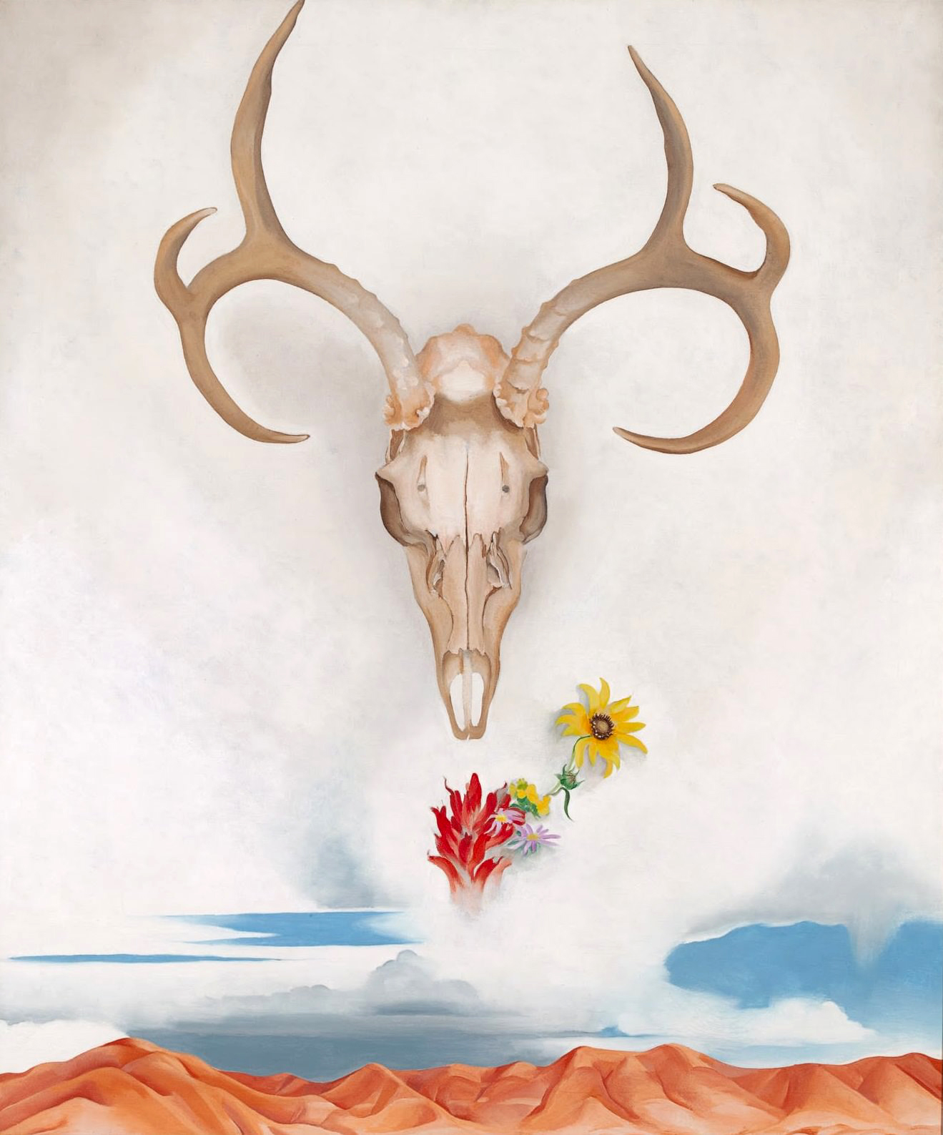
Summer Days, Georgia O’Keefe, Oil on canvas, 36 1/8 x 30 1/8 inches, 1936

In coming upon “Summer Days”, we are immediately confronted to an object, a skull, a remainder. And to silence; I can “hear” the high noon stillness of the desert, sun in my eyes, the skull as an afterimage, a mirage. And yet I’m confounded. Shouldn’t this thing, this bone, sun-bleached and sanded, be found at my feet, not elevated above me, floating, noble and majestic, as a cipher? By what fantasmatic turn, magical or shamanistic alchemy, does this litter, the remains most likely of a violent event – predacious, yet not left by a hunter, who would have extracted the antlers as a trophy – come to embody something sacred, totemic. Detritus as deity, sacrosanct, holy. The flowers and the approaching storm on the horizon provide a clue. It’s a still life, vantias, memento mori. But there’s something else, ineffable yet hidden in plain sight. The anamorphic skull in Holbein’s “The Ambassadors” comes to mind. Although O’Keefe’s skull is not apperceived as a stain on a carpet, it’s no less compelling as a formation in the clouds, a glyph, divination in the bone, traveling in the opposite direction, not a fallen object but an elevated one. It seizes me, looks back at me.

Essentially, all artwork is organized around a hole or void, yet incorporates or betrays it. In “Summer Days” this is the emptiness of the desert, the divots in the skull, or the eye sockets. O’Keefe explicitly raises an object to the dignity of the Thing, that object, forever lost, which lies beyond any possible representation or depiction. In “Summer Days”, the primordial existence of that thing is uncannily implied. The deer skull resonates simultaneously as something imagined and something real, a cast-off, leftover, otherwise forgotten, which O’Keefe salvaged, I imagine, having come aimlessly across it in the desert, or better, it came across her. She was seen, caught by its gaze, which may be why she chose to memorialize it, as Thing, talisman, symbol – something characteristic of the sublime – or in hypermodernity what is known as the Real. She explicitly renders creation ex nihilo, confronting the void in order to screen or embroider it. The desert is represented as a space to be filled, an emptiness that introduces the necessity to fill it. This is the works central paradox: we wouldn’t be aware of a void if the painting wasn’t created in order to plug it. A figure-8. In another words, what is a hole if nothing surrounds it?

I think of “Summer Days” less as a portrait than a portrayal, an index of the transfiguration of the remainder into the icon or sign. Sublimation. I’ve been making a series of paintings entitled “The Letter! The Litter!”, canvases that are my embellished transcriptions of scraps of writing I find on the street, discarded or lost remainders of a correspondence, diary, or publication – a life. Like O’Keefe did, I spend time in the West, in the low and austere desert of far southwest Texas, along the border with Mexico. I search there too for traces, parts, bits and pieces.

My mother was an artist, a Sunday painter. She was adventurous, but as a woman in the era of “Mad Men”, she didn’t travel often or far. However, as a young woman she sojourned in New Mexico. Starting 2002, in the wake of 9/11, I began taking exploratory trips out West, choosing towns on the map that called to me by their name. One of those towns was “Truth or Consequences”, NM. From there I made my way north to Taos, where my mother had gone, and O’Keeffe too. I was aware of O’Keeffe’s paintings as a teenager. They were exotic, yet because they were omnipresent, stereotype and cliché. They still can be, which is in part why I wanted to address her work. I encountered “Summer Days” in the museum in a manner analogous to O’Keefe’s coming across a skeleton on the desert floor. “Summer Days” is an allegory for this transfiguration of the skull to Thing to art, littered by the artist’s body, salvaged by the museum. O’Keefe’s work circulated in the age of mechanical reproduction, which is how I originally encountered it. But what about it, or any work, in the digital age of sliding, liking, swiping? In the ocean of images it’s the something “else”, singular, disturbing, that beckons each of us individually, that object or image that causes a disturbance, akin to the punctum that smote Roland Barthes when finding in a photograph the “air” of his own Mother.

I’ve lately been interested in the Feast of the Transfiguration of Christ. Although I was raised Catholic, I was unaware of this holiday, one which I can celebrate, not only spiritually but artistically. Art is nothing if not an act of transfiguration of the object as I’ve been saying. The Transfiguration is exemplified by “Summer Days”, the skull forming an axis between heaven and earth, radiating a kind of fantasmatic light, as we bear witness to it. The paradox, poignancy, depicted in the painting is that to love or venerate a thing is also to kill it, to mutilate it, to extract from it something more than it, beyond it.

Only after I chose to respond to “Summer Days” did I glimpse through it the act of changing my father’s name, by a single letter from Beck to Buck, as a maneuver to raise the status of the Name-of-the-Father but precisely as an artifact, a left-over, a hand-me-down. The Name-of-the-Father changed irrevocably in the 20th Century, causing each of us to invent our own, knowingly, explicitly, or not. (Caitlyn Jenner would be a recent, obvious, and high profile example.) I did so literally, with a simple exchange of vowels, as a means to call attention to this evolution. Buck: stag, son, cash, dislodge.

O’Keefe venerates the buck not only as a hunter would but as an artist, and this is how I came to understand “Summer Days”, among many other things, as a kind of notary for the name I made for myself, through art, the only discourse in which it matters, signifies, or creates effects. Fortuitously, not long ago, I came across a quote from the psychoanalyst Jacques Lacan, “One can do away with the Name-of-the-Father as long as one makes use of it.”

Robert Buck, October 6, 2016

